PES UNIVERSITY
DEPARTMENT OF COMPUTER SCIENCE & ENGINEERING
Software Engineering Lab (PES_SE_B_2026B)
Lab 6: Code and Branch Coverage Analysis

Student Name: | Deeksha G
SRN: | PES1UG24AM078
Assigned Program: | student_grades.py (Repo 16)
GitHub Repository: | https://github.com/DEEKSHAGURURAJA/L6_L7_16_student_grades

1. Objective
The objective of this lab is to measure, analyze, and improve code coverage and branch coverage using Python's pytest and coverage tools. Specifically, we aim to:
1. Identify the difference between line (statement) coverage and branch (decision) coverage.
2. Write test cases targeting 90%-100% statement coverage for the assigned student_grades module.
3. Write test cases targeting 90%-100% branch coverage by evaluating all true/false decision branches.
4. Follow Git workflow best practices by creating at least two distinct commits for code and branch coverage.

2. Program Under Test (student_grades.py)
The assigned application contains three main functions:
• letter_grade(marks): Converts a numerical mark (0 to 100) into a letter grade (S, A, B, C, D, E, F). Raises ValueError for invalid marks.
• final_marks(internal, external, has_project): Sums internal (max 40) and external (max 60) marks. Adds a 5-mark project bonus if applicable, capped at 100.
• exam_eligibility(attendance, fees_paid, has_medical): Evaluates student exam eligibility based on attendance percentage, fee payment status, and medical condition.

3. Part 1: Code Coverage (Statement Coverage)
Statement coverage ensures that every line of code inside student_grades.py is executed at least once during test execution.
Test file created: CodeCoverageTest_student_grades.py
Test design highlights:
• test_letter_grade_all_statements: Tests negative marks (-5) to trigger the ValueError line, and checks sample values for S, A, B, C, D, E, and F to hit all return statements.
• test_final_marks_all_statements: Tests internal > 40 to trigger the ValueError statement, and tests a scenario with project bonus to hit the bonus addition and 100-cap lines.
• test_exam_eligibility_all_statements: Tests fees unpaid ('blocked'), high attendance ('eligible'), medical condonation ('eligible'), and low attendance ('detained').
Execution Commands:
coverage erase
coverage run -m pytest CodeCoverageTest_student_grades.py
coverage report -m

Terminal Output Screenshot (Code Coverage - 100%):
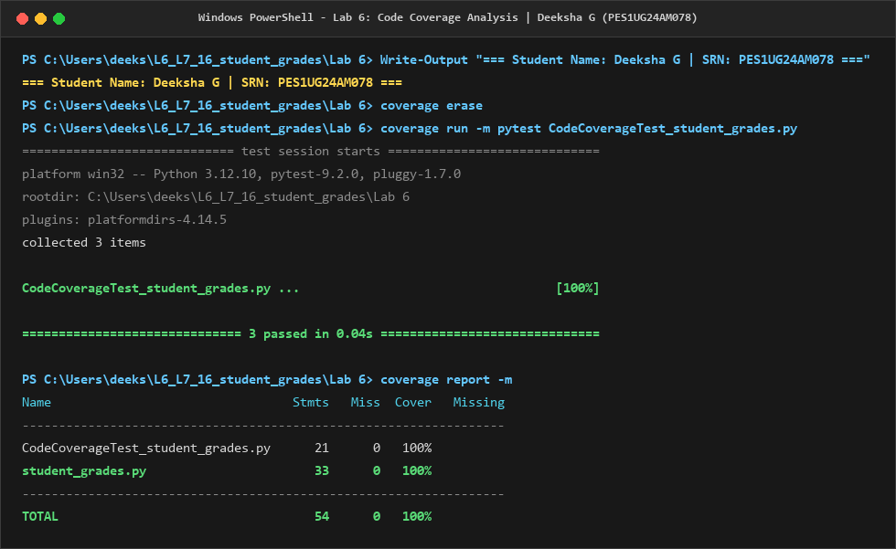

4. Part 2: Branch Coverage Analysis
Branch coverage requires that every decision point (if, elif, and compound conditions) evaluates to both True and False at least once.
Why line coverage alone was insufficient:
Under 100% line coverage, certain decision pathways were still untested. Specifically:
• final_marks with has_project=False (skipping the bonus addition block entirely).
• final_marks with has_project=True where total <= 100 (skipping the cap at 100).
• marks > 100 condition in letter_grade (previously only tested negative marks for ValueError).
• attendance between 65 and 75 with has_medical=False in exam_eligibility.
Test file created: BranchCoverageTest_student_grades.py
A total of 13 targeted test functions were implemented to thoroughly test all 26 control branches.
Execution Commands:
coverage erase
coverage run --branch -m pytest BranchCoverageTest_student_grades.py
coverage report -m

Terminal Output Screenshot (Branch Coverage - 100%):
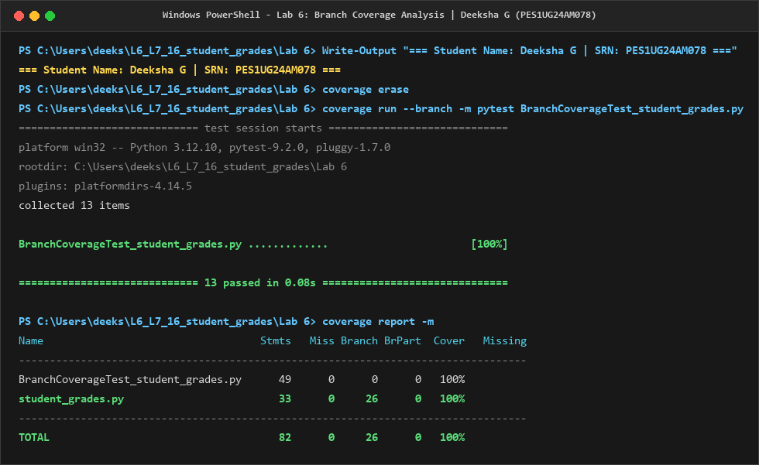

5. Coverage Summary Comparison
Metric / Suite | Statements | Missed Lines | Branches | Coverage %
Code Coverage (CodeCoverageTest) | 33 / 33 | 0 | N/A | 100%
Branch Coverage (BranchCoverageTest) | 33 / 33 | 0 | 26 / 26 | 100%

6. Version Control and Deliverables
As required by the assignment guidelines, changes were staged and committed in two distinct commits:
1. Commit 9d4f408: Added CodeCoverageTest_student_grades.py and code_coverage_analysis.png.
2. Commit b25ae9a: Added BranchCoverageTest_student_grades.py and branch_coverage_analysis.png.
All commits have been successfully pushed to the GitHub repository: https://github.com/DEEKSHAGURURAJA/L6_L7_16_student_grades

7. Conclusion
Through this experiment, I learned that 100% statement coverage does not guarantee that code is free from untested logical paths. Branch coverage provides a more rigorous verification by forcing tests to validate both True and False outcomes of every conditional branch. Using Python's coverage library, I achieved 100% line coverage and 100% branch coverage across all functions in student_grades.py.

